**Name:** Priya Lakhotiya

**Enrollment No.:** 180089

**PROGRAM- 14**

**Aim:** Write an algorithm and program to implement Matrix-Chain Multiplication.

**Algorithm:**

Begin

define table minMul of size n x n, initially fill with all 0s

for length := 2 to n, do

fir i:=1 to n-length, do

j := i + length – 1

minMul[i, j] := ∞

for k := i to j-1, do

q := minMul[i, k] + minMul[k+1, j] + array[i-1]*array[k]*array[j]

if q < minMul[i, j], then minMul[i, j] := q

done

done

done

return minMul[1, n-1]

End

**Source code:**

#include<iostream.h>

#include<conio.h>

int matrixChain(int n, int order[])

{

int i,j,k;

int tempValue;

int dp[50][50], INT_MAX=10000;

for(i=1;i<=n;i++)

{

dp[i][i]=0;

}

for(int size=2;size<=n;size++)

{

for(i=1;i<=(n-size+1);i++)

{

j=i+size-1;

dp[i][j]=INT_MAX;

for(k=i;k<j;k++)

{

tempValue=dp[i][k]+dp[k+1][j]+order[i-1]*order[k]*order[j];

if(tempValue<dp[i][j])

{

dp[i][j]=tempValue;

}

}

}

}

return dp[1][n];

}

void main()

{ clrscr();

int i,j;

int n;

cout<<"Enter the number of matrices in the chain(greater than 1) ";

cin>>n;

int order[50];

cout<<"Enter the order array of the matrix chain ("<<n+1<<" elements)"<<endl;

for(i=0;i<=n;i++)

{

cin>>order[i];

}

cout<<"The minimum number of multiplication operations required to multiply the matrix chain is "<<matrixChain(n,order);

cout<<endl;

getch();

}

**OUTPUT:**

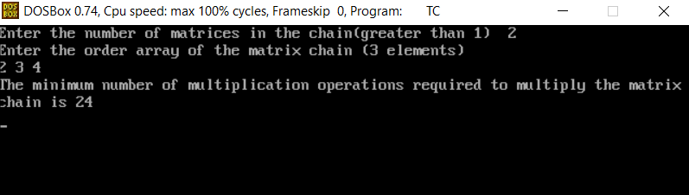

**Complexity:**

O(n3)